BÁO CÁO THỰC HÀNH LAB 5  
LẬP TRÌNH HƯỚNG ĐỐI TƯỢNG

# GUI Programming

## 1. Swing components

#### 1.1. AWTAccumulator

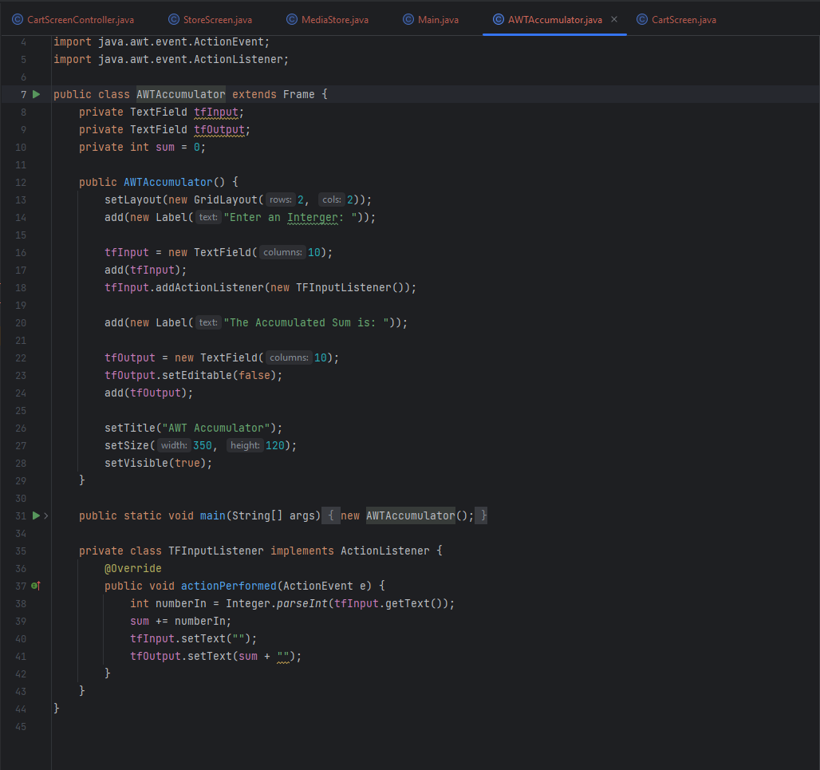

#### 1.2. SwingAccumulator

## 2. Organizing Swing components with Layout Managers

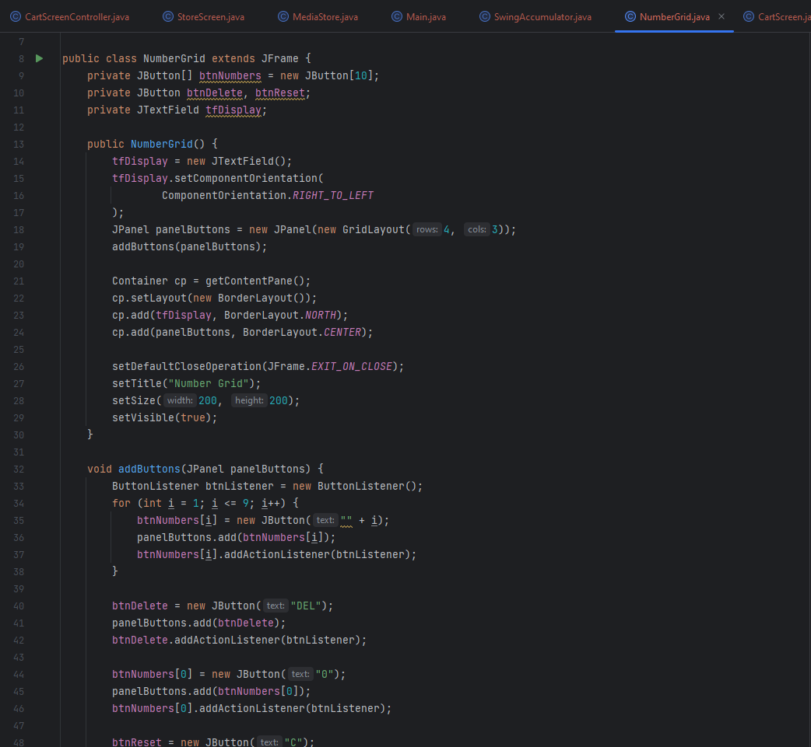

## 3. Create a graphical user interface for AIMS with Swing

## 4. JavaFX API

## 5. Setting up the View Cart Screen with ScreenBuilder

## 6. Integrating JavaFX into Swing application – The JFXPanel class

## 7. View the items in cart – JavaFX’s data-driven UI

## 8. Updating buttons based on selected item in TableView – ChangeListener

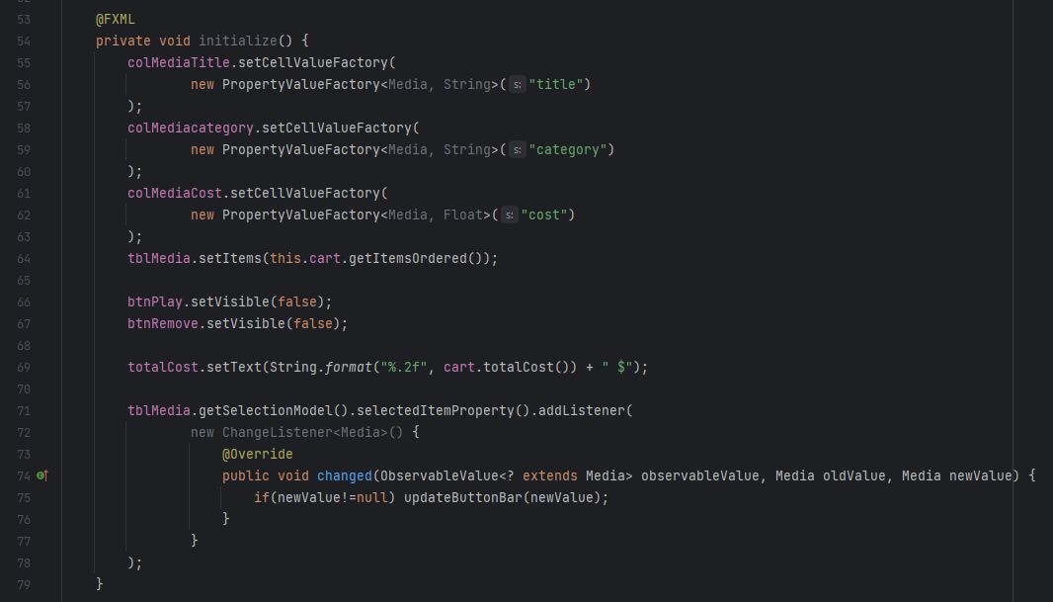

## 9. Deleting a media

## 12. Sort media in the cart

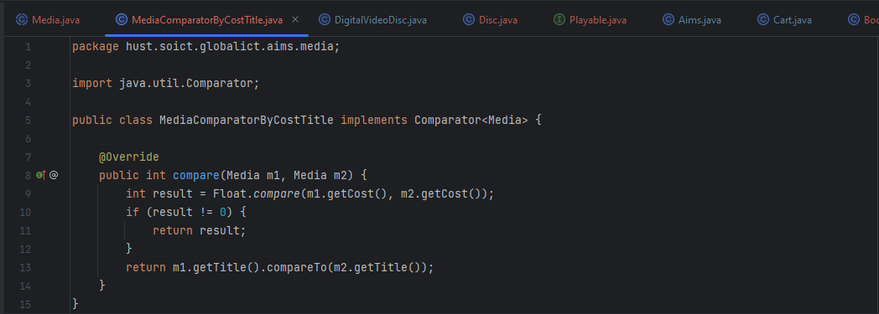

## 13. Create a complete console application in the Aims class

